Young Vietnamese increasingly turning to online news sources over state TV

V
ietnam’s government-run VTV television network continues to dominate the country’s media landscape. However, the current survey also points to a powerful generational shift in media use toward online news sources and less dependence on state TV.
This trend is perhaps more clearly reflected in the results when Vietnamese adults are asked to name the three media outlets that are their most important sources of information. While almost three-fourths of those age 35 and older (74.1%) include VTV among their responses, less than half of those age 15-34 (48.6%) do so. Young people, in turn, are more likely to name online sources — most commonly the popular Vietnamese news and information portals 24 Gio and Dantri.com, and the global social media giant Facebook.

Media Platforms in Vietnam
Television
Television remains Vietnam’s media platform. Almost all Vietnamese adults say they watch TV at least weekly, regardless of demographic category. National VTV stations reach more than nine in 10 adults (91.6%) every week, far more than any other network. Most of the country’s 64 provinces have their own government-controlled stations, and almost eight in 10 adults (78.9%) say they watch their provincial channel weekly or more.
Nationwide, 38.0% of Vietnamese television owners say their TV signal comes from a terrestrial antenna, while 25.1% use a satellite dish and 27.4% have cable TV. Cable service has grown significantly more common since the 2012-2013 study, while use of conventional antennas has fallen somewhat.
Radio
About one in four Vietnamese (24.8%) now say they listen to the radio weekly or more, down marginally from 27.6% in the 2012-2013 study. The FM band is by far the most commonly used, with 3.8% of Vietnamese saying they listen to AM radio and 1.0% listening 6to shortwave radio on a weekly basis. Notably, Vietnamese are now about as likely to have listened to the radio on mobile phones (10.3%) as on conventional radio sets (11.1%) in the past week.
Internet
Frequency of TV and radio use have changed little since the previous survey, conducted in late 2012 and early 2013. By contrast, the proportion of Vietnamese adults who use the Internet weekly or more continued to rise, from 26.3% in the earlier survey to 38.8% today. Among those who live in urban areas, that figure has surged from just over one-third (34.7%) in 2012-2013 to more than half (51.8%) currently.
However, as Internet access has spread in Vietnam, the state has increasingly sought ways to control the flow of online information it considers threatening. Media watchdog groups like Reporters without Borders commonly condemn the jailing or harassment of bloggers for, in the Vietnamese government’s terms, “abusing democratic freedoms.”
As in most developing markets, the prevalence of Internet use in Vietnam is particularly uneven among age and education groups. Two-thirds of adults under age 35 (and 78.5% of those age 15 to 24) say they’ve gone online in the past week, vs. just 15.8% of those 35 and older. Similarly, 69.0% of Vietnamese with post-secondary (vocational or college) education use the Internet weekly, vs. 18.2% of those who have not completed middle school.
With regard to social media use in Vietnam, Google Plus, Facebook and YouTube represent the top tier of services, each used by more than one-fourth of all adults and a majority of those age 15-24 on a weekly basis. Zing Me, a social networking service that caters specifically to the Vietnamese population, and the Vietnamese instant messaging app Zalo follow, both used weekly by almost one-fifth of adults overall.

Mobile phones
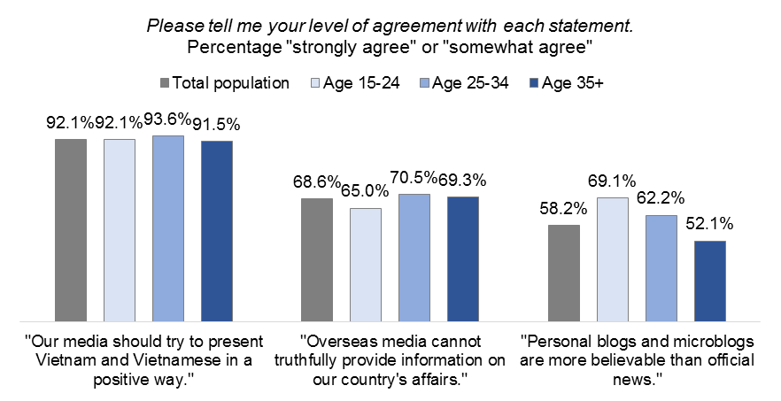
A key factor in rising Internet use in Vietnam is the growing availability of web-enabled phones and other mobile devices. Over the past decade, the government has supported an aggressive expansion of the country’s mobile data infrastructure to spur economic growth. Rising living standards have also fueled the expansion of Vietnam’s smartphone market in recent years.
One result is that mobile phones have become the primary means of accessing the Internet in Vietnam, with eight in 10 weekly web users saying they used their mobiles to go online in the past seven days. By contrast, less than half (45.5%) say they have used a desktop computer to do so, and just over one-fourth (26.5%) have used a laptop.
About three in 10 Vietnamese overall (30.6%) say they use mobile apps, similar to the proportion who say they have accessed the Internet on a mobile phone in the past week. Those who do use mobile apps were asked to name the three they use most frequently. Facebook is the most commonly mentioned, included among their three possible responses by 71.9% of mobile app users, followed at a distance by the instant messaging app Zalo (44.6%) and Google (40.0%). Zalo was launched by Vietnam’s leading Internet company VGN in 2012, and has grown rapidly with an aggressive marketing strategy and a singular focus on the Vietnamese market.

Use of and Attitudes toward News Media
Despite the country’s restrictive media environment, Vietnamese are extremely avid news consumers; almost nine in 10 adults (88.0%) say they access some type of
news at least daily while almost all (96.8%) do so at least once a week. There is little difference among education or age categories in these results.
Almost all Vietnamese are comfortable with the idea that media organizations should advocate national interests; 92.1% strongly or somewhat agree that Vietnamese media should present the country and its people in a positive way. Further, more than two-thirds (68.6%) say they don’t believe overseas media can truthfully cover Vietnamese affairs.
However, most Vietnamese (58.2%) believe personal blogs are more believable than official news, pointing to an underlying distrust of state media, particularly among younger and better-educated adults who are most likely to use blogs and other online information sources.

Methodology
This report contains results from a nationally representative, face-to-face survey of 3,000 Vietnamese residents aged 15 and older. The survey is representative of 58,563,000 adults in Vietnam (based on the estimated 15-and-older population from the Population Reference Bureau). Interviewing was conducted between January 20 and March 13, 2015. The national sample is weighted by age, gender, education, region and urban vs. rural residency based on data from the Vietnamese General Statistics Office and the Vietnamese National Census.

Contact
For any questions or further information on these data, please contact the Broadcasting Board of Governors at publicaffairs@bbg.gov or 202-203-4400. Follow us on twitter at @BBGgov.

